DSA Lab10

23K2001

M.Muzammil Siddiqui

BCS-3J

Q1:

// AVL trees keep themselves balanced, so they’re faster for searching, inserting,

// and deleting compared to regular binary trees. The balance makes them efficient,

// especially when data is constantly being added or removed.

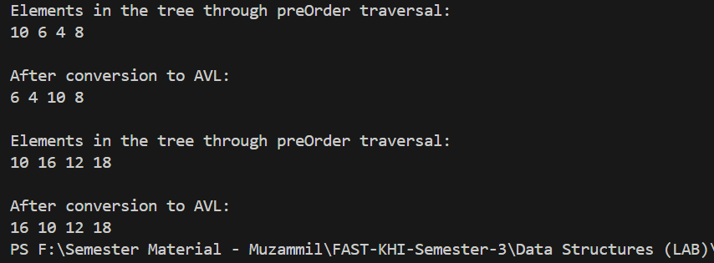Q2:

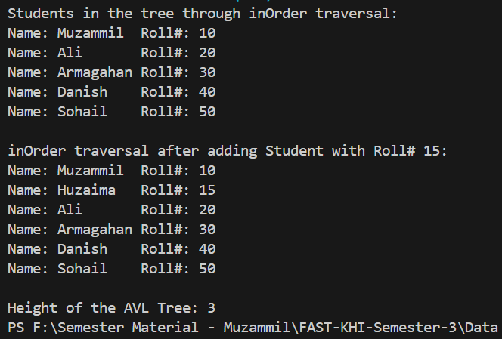

Q3:

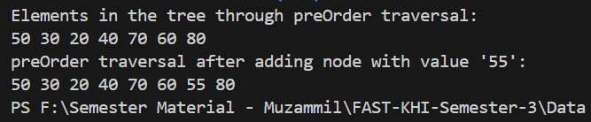

Q4:

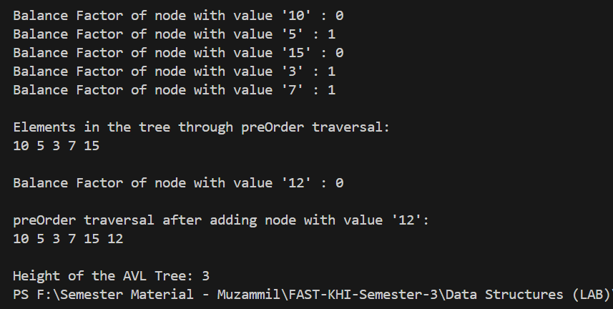

Q5:

